Lord of the Nutcracker Men, 2 3-9 bas
Stand to | Most of the time they were in the trenches, the soldiers are sitting or leaning. Twice a day, at dawn and at dusk, the sergeant gave the order “Stand to!” The soldiers must stand at attention with their rifles at their sides. |  |  | Soldiers in the trenches must stand at attention when the sergeant calls out:  _____________________
Airplanes in World War I | The Wright Brothers were the first to fly an airplane. Their first flight, on December 17, 1903, lasted 12 seconds. Ten years later, military planners were thinking of new uses for flying machines.  World War I was the first war fought with airplanes. The original use of airplanes in the war was to gather information. Planes could fly over an area and see where the enemy was positioned.  Later, guns were attached to planes; pilots shot down at troops, and pilots shot at each other. Fighter pilots became heroes as each one counted the number of planes he shot down. An air battle was called a dogfight. Bombs were loaded onto planes, and pilots flew over an area and dropped the bombs.  The British companies Vickers and Sopwith made airplanes for the military. The German company Albatros-Flugzeugwerke served the German military. |  |  | 1. In what year was the very first airplane flight?  __________  2. What was the first war to use airplanes?  ________________  3. What was the first use of airplanes in the war?  _____________________________  4. When one fighter pilot was shooting at an enemy fighter pilot in an air battle, what was that called?  ______________________  5. What were two British companies that made airplanes for the military in World War I?  _____________ and _____________  6. What was the name of the German company that made airplanes for combat?  ______________________________  ______________________________
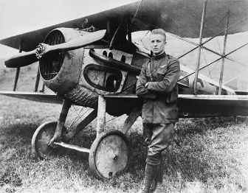 |  | 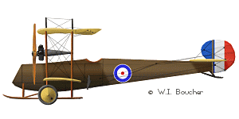 | 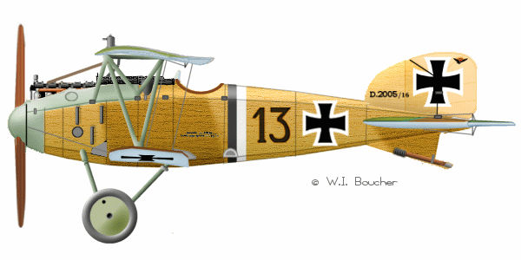 |  | 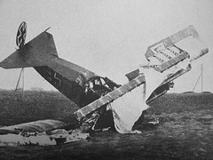
A fighter pilot |  | Vickers E F B 7 | Albatross F F 2 9 |  | A fighter plane
Lord of the Nutcracker Men, 2 N _______________ 3-9 bas
D _______________ C _______
Identification  Tags | Each soldier wore two identification tags, now called dog tags, around his neck. The soldier’s name, place of birth, unit of the army, and serial number were stamped on the tag. |  |  | What do we call soldiers’ identification tags?  _____________________
Self-Inflicted Wound | Soldiers in trenches, desperate to get out, sometimes shot themselves.  For example, a soldier would shoot himself in the foot so he could be removed from the trench and taken to a hospital behind the lines to recover.  However, it was a crime to shoot yourself to avoid military service. The official punishment was to be shot.  Over three-thousand British soldiers were convicted of self-inflicted wounds; none was shot, but all were sent to prison. |  |  | Why would a soldier in a trench decide to injure himself?  I think ____________  __________________  __________________ .  How many British soldiers injured themselves on purpose?  ___________________________
Christmas Truce, 1914 | The first Christmas of the war, in 1914, some German and British soldiers spontaneously climbed out of their trenches and met in the middle of no-man’s-land. Soldiers who were there wrote letters home about it, and later they described the events in great detail. By the next Christmas, in 1915, soldiers were given strict orders not to be friendly with the enemy. |  |  | What year was the  Christmas truce? ____________  Where did German and British soldiers meet?  __________________  What do you think a general would say about a truce the next Christmas?  I think _____________  __________________  _________________
Christmas Traditions | German culture celebrates the Christian festival of Christmas with songs about the birth of Jesus. British culture has translated these songs. “Silent Night” is the German Christmas carol “Stille Nacht.” |  |  | The English Christmas song “Silent Night” is based on the German Christmas song called  ___________________________

