Review Sheet for the Final Exam 6th grade Social Studies 2017

Europe
Please label all of these physical features and countries:
Danube River, Rhine River, English Channel, Mediterranean Sea, European Plain, the Alps, Pyrnees, Ural Mountains, Iberian Peninsula, Scandinavian Peninsula, Belgium, France, Germany, Italy, Poland, Russia, Spain, Ukraine, and the United Kingdom

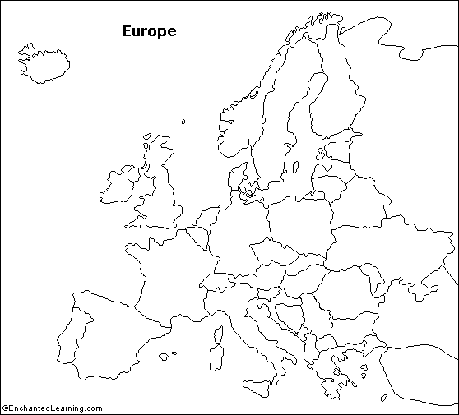

1. What are the 3 environmental problems of Europe? Where are they?

2. Explain the 3 major religions of Europe. Which one is the most prevelant?

How are the 3 religions similar?

How are they different?
History
3. What is colonization?
What are the 3 G’s?
4. What is industrialization?
5. Describe why WW1 started?
What are the 2 sides?
6. What was the Russian Revolution and its aftermath?
Mutiny
Strike
Why did it occur?
Who are the major players?
Marx
Lenin
Tzar Nicholas II
7. Explain the 4 parts of the Treaty of Versailles.

8. Why was the US more lenient than France was in the treatment of Germany after the war?
9. What was the Great Depression?
How did it effect Germany
10. Explain Hitler’s rise to power, include dates.
When did WW2 officially start?
11. How did WW2 lead to the Cold War?
12. Who are the major players in the Cold War?
What is the Eastern Bloc
What is the Warsaw Pact?
13 What was the Berlin Wall
14. What was the Iron Curtain?
15. Who was Churchill?
Economy
16. Why was the European Union established?
17. Who’s in the EU?
18. Why should the British get out of the EU (Brexit?

19. Why should the British stay in the EU?

20. What is the Triangle Trade?
21. Put these countries on the continuum below:
Russia, US, Germany, United Kingdom, Canada
Market___________________________________________________________Command
Government
22. Describe these government terms:
Unitary
Confederation
Federal
Autocratic
Oligarchic
Parliamentary Democracy
Presidential Democracy
Constitutional Monarchy
23. What types of government does Russia have?
What types of government does United Kingdom have?
What types of government does Germany have?
What types of government does Canada have?

Canada
Label these physical features on the map below: Atlantic Ocean, Pacific Ocean, Hudson Bay, Canadian Shield, Rocky Mountains, Great Lakes and St. Lawrence River
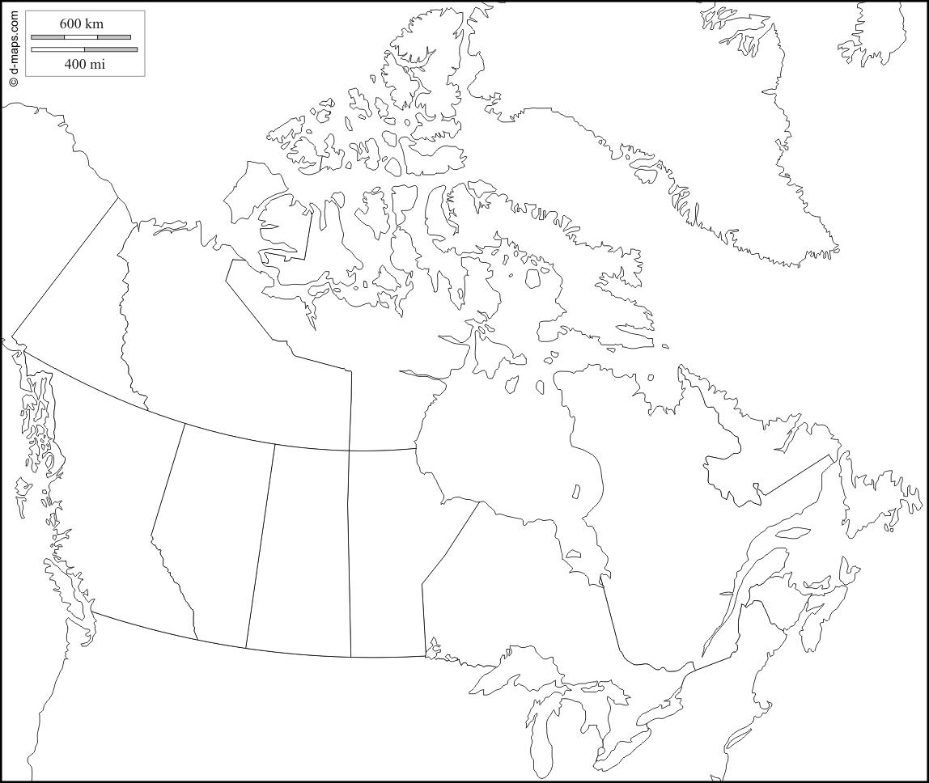

24. What are the major environmental problems of Canada?

History
25. Who are the 1st Nations?

26. What was the Quebec Act?

27. Why do they speak French and English in Canada?

