Lord of the Nutcracker Men, 2 3-9 cha
Stand to | Most of the time they were in the trenches, the soldiers are sitting or leaning. Twice a day, at dawn and at dusk, the sergeant gave the order “Stand to!” Then the soldiers must stand straight at attention with their rifles at their sides.
Airplanes in World War I | The Wright Brothers were the first to fly an airplane. Their first flight, on December 17, 1903, lasted 12 seconds. Ten years later, military planners were thinking of new uses for flying machines. World War I was the first war fought with airplanes. The original use of airplanes in the war was to gather information. Planes could fly over an area and see where the enemy was positioned. Later, guns were attached to planes; pilots shot down at troops, and pilots shot at each other. Fighter pilots became heroes as each one counted the number of planes he shot down. An air battle was called a dogfight. Bombs were loaded onto planes, and pilots flew over an area and dropped the bombs. The British companies Vickers and Sopwith made airplanes for the military. The German company Albatros-Flugzeugwerke served the German military.
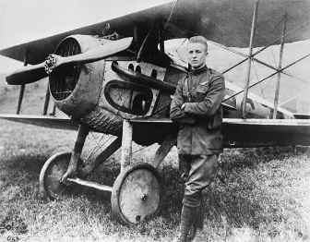 |  | 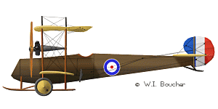 | 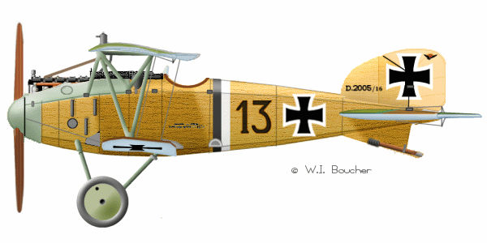 | 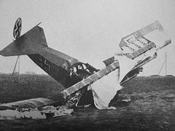
A fighter pilot |  | Vickers E F B 7 | Albatross F F 2 9 | A fighter plane
Identification  Tags | Each soldier wore two identification tags, now called dog tags, around his neck. The soldier’s name, place of birth, unit of the army, and serial number were stamped on the tag. When a soldier died, the red tag was taken to record the death; the green tag stayed with the body.
Self-Inflicted Wound | Soldiers in trenches, desperate to get out, sometimes shot themselves. For example, a soldier would shoot himself in the foot so he could be removed from the trench and taken to a hospital behind the lines to recover. However, it was a crime to shoot yourself to avoid military service. The official punishment was to be shot. Over three-thousand British soldiers were convicted of self-inflicted wounds; none was shot, but all were sent to prison.
Christmas Truce, 1914 | The first Christmas of the war, some German and British soldiers spontaneously climbed out of their trenches and met in the middle of no-man’s-land. Soldiers who were there wrote home about it, and later they described the events in great detail. All military systems have strict rules against fraternization, or being friendly with the enemy. By the next Christmas, in 1915, soldiers were given strict orders not to fraternize with the enemy.
Christmas Traditions | German culture celebrates the Christian festival of Christmas with songs about the birth of Jesus. British culture has translated these songs. “Silent Night” is the German Christmas carol “Stille Nacht.” Decorating an evergreen tree with candles on Christmas Eve was a German tradition that people in Britain admired and copied.

Lord of the N_____________________ 3-9 cha
Nutcracker Men, 2 D ______________ C _______
The author Iain Lawrence creates an imaginary story loaded with precise facts—historical fiction.

Try to remember three very specific facts from World War I that the author uses in the book. | Think of three specific details that are completely imagined by the author.
You are the author, Iain Lawrence. Someone asks you, “Why did you write a book about war?”
Here are four quotes from the book. Who said this? Imagine what comes next. Use all the space.
1. “I did it to myself, Johnny. I couldn’t __________________________  ________________________________________________________________.” |  | Who is this?  ____________  ____________
2. “Oh, some wars last a hundred __________________________________  _______________________________________________________________.” |  | Who is this?  ____________  ____________
3. “I am glad to be working to help end this horrible ___________________  _______________________________________________________________.” |  | Who is this?  ____________  ____________
4. “No parcel in the world is big enough to hold all of my ____________  ______________________________________________________________.” |  | Who is this?  ____________  ____________
Private James Briggs describes  Christmas Eve, 1914. | German soldier Willy Kempf describes Christmas Eve, 1914.
Pretend you are the German pilot of an Albatros FF 29 fighter plane. You are flying over a tiny British village on Christmas morning, 1914. What do you see? What do you do? How do you feel?

