Europe: Natural Resources 3-2 bas
location | Location is where something is. The location of a country is where it is on the surface of the earth. Is it a lonely island, or is it surrounded by neighbors? Is it in a desert, or in a rainforest? Is it near the equator, or in the frozen north? | Our country is an __ __ __ __ __ __  surrounded by water.  Well, our country is a __ __ __ __ __ __  with a tiny amount of rain each year.  Well, our country is so far north that we are always __ __ __ __.
climate | Climate is the general pattern of temperature, wind, and precipitation in an area. (Weather is the climate on a particular day.) A country near the equator will be sunny and have a very hot climate. High mountains give a country a cold and snowy climate. | Hot today, rain tonight; that’s the  __ __ __ __ __ __ __ for today.  Our country has warm summers, cool winters, and lots of sunshine.  That’s our __ __ __ __ __ __ __.  Countries near the equator have a  __________ and _____ climate.  Countries with mountains have a  _______ and _________ climate.
natural resources | Natural resources are gifts from nature. Minerals deep under the ground are iron, gold, zinc, diamonds. Oil and coal under the ground are energy sources. Rivers, lakes, and ocean coasts are natural resources for a country. Soil for farming is a natural resource; so are forests. | Thank you, nature, for all these great  __ __ __ __ __ __ __  __ __ __ __ __ __ __ __ __.  They help our country succeed.  Under the ground we have energy  sources like __ __ __ and __ __ __ __.  We can have successful farms with our great __ __ __ __.
population distribution | Population comes from the Latin word for people.  Distribution is how spread-out or clumped-together people are.  Do most people in a country live in cities, or is everybody scattered in small villages and farmland? | The word for people is  __ __ __ __ __ __ __ __ __ __  The word for how spread out or crowded together people are is  __ __ __ __ __ __ __ __ __ __ __ __
Do most people live in the east or west?
_______

Europe: N___________________ 3-2 bas
Natural Resources D____________ C________
United Kingdom | The United Kingdom is an island off the northwest coast of Europe. It has mild temperatures with rain. The mountains have coal and iron, and the soil in the south is good for farming. Most people live in cities; eight million people live in the capital city, London. |  |  |  | On this map of the United Kingdom,  show mountains in the west.  Show a coal truck in the west for coal.  Show crops growing in the south.  Show a big city at the L for London. |  | 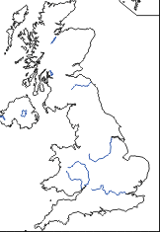
Russia | Most of Russia is big, cold, and empty. It is the largest country in the world in size, and it makes the northern edge of Europe and Asia.  It is extremely cold; the average yearly temperature is below freezing. Over 60% of the Russian land is frozen solid all year. Russia has huge forests and farmland in the European Plain. Most Russians (75%) live in the European west side.
What’s the biggest country? __ __ __ __ __ __
How cold is it? More than half of the land is completely __ __ __ __ __ __ all year.
What mountains are these?
Where do 75% of people live, east or west?
Most people live in the _______.
Germany | Germany is in the northern center of the European Plain. On the Atlantic Ocean coast, the temperature is cool. In the south near the Alps, it is cold and snowy. Germany has coal in the mountains, farming on the Plain, and river transport. Around 75% of Germans live in cities.
Italy | Italy is a peninsula in the Mediterranean Sea in southern Europe. It is covered in small mountains. Northern Italy is in the snowy Alps. The rest of Italy is sunny and warm all year. The hills of Italy have small farms growing grapes and olives. Fish in the sea are a resource. Most people (75%) live in cities.
 |  | On this map of Germany, label the landforms:  1. Alps in the south.  2. Rhine River flows north  3. Danube River flows southeast.  4. Atlantic Ocean in the north.  Make drawings to show  5. Coal in the west.  6. Farming in the center. | 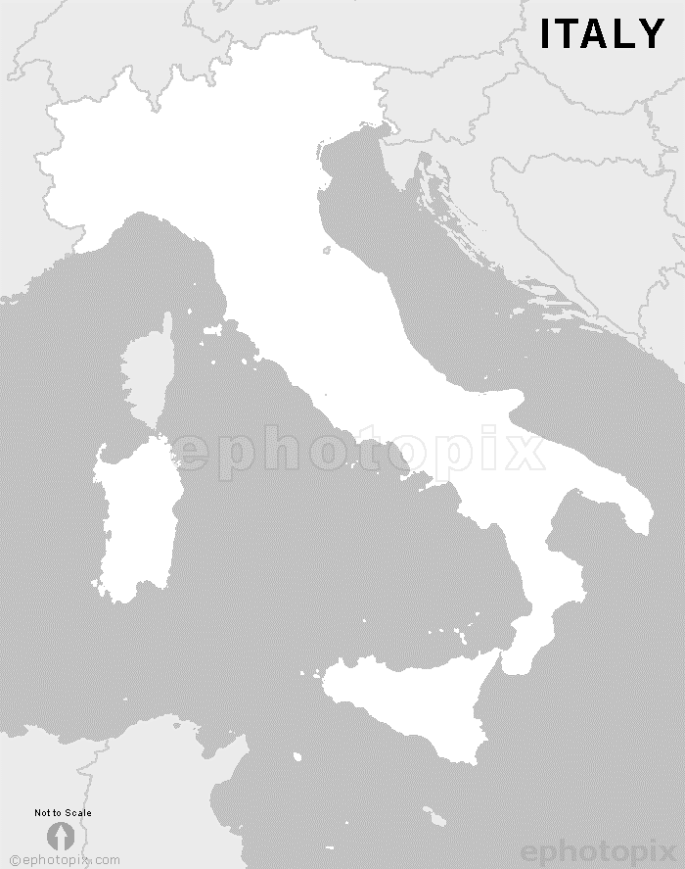 |  |  | On this map of Italy, label the landforms.  1. Mediterranean Sea  2. Alps in the North  Make drawings to show  3. Little mountains all over.  4. Fish in the sea  5. Alps in north

